|  |  |  |  |  |
| --- | --- | --- | --- | --- |
| **AutoPilot Client Installation Process** | | | | |
|  | Author | Gargi Sinha | Created | 10/23/2014 |
|  | Document Stability | Released | Last Updated | 11/01/2014 |

**Sign Off**

|  |  |  |
| --- | --- | --- |
| **Group** | **Name/alias** | **Date** |
| Software Engineer | Peter | 10/28/2014 |
| Engineering Lead | Vishnu | 10/29/2014 |
| Program Manager | Cesar | 10/30/2014 |

**Change History**

|  |  |  |  |
| --- | --- | --- | --- |
| **Date** | **Version** | **Changes made** | **Author/Contributors** |
| 11/01/2014 | 1 | Initial relaease | Gargi Sinha |

Contents

1 Introduction 2

2 Scope 2

3 AP Client Specific Switches 2

4 Prerequisites 2

5 Risks 2

6 AP Client install process validation 2

7 Installation 3

8 Verify successful install 3

9 Uninstalling AP Client through Service 4

10 Uninstalling AP Client manually 4

11 Questions? 5

1. **Introduction**

AutoPilot (AP) Client is a lightweight stack that runs on existing data center servers. It enables AP to manage application services even though hardware provided are different from the standard SKU. AP's deployment features – Applications, Data, Configuration files and Monitoring are available.

Windows Service is designed to provide support to automatically install and manually repair   
AP Client. Service must be run from the command line application console as an “Administrator”.

1. **Scope**

This document provides insight into AP Client installation, uninstallation and manual repair processes.

1. **AP Client Specific Switches**

Windows Service have introduced new Boolean type switches for AP Client. The switches mentioned below are not case sensitive.

* /APCLIENT
* /APCLIENTREPAIR
* /APCLIENTREMOVE

To install or repair, use /Only switch in combination with the above switches.

1. **Prerequisites**

The pre-requisites for installation are as follows:

1. Machine must be in an AP cluster to install AP Client.
2. Manual configuration is required prior to AP Client install.
3. **Risks**

In case of failing to perform AP Client configuration on IronMan, the server will go to a permanent limbo state. By manually performing several tasks on the server, which includes removing the AP bits this can be fixed.

In order to mitigate this risk, the /APCLIENT switch will remain optional on the Service. At the time of release customers will be informed regarding this feature and the risk of using it.

1. **AP Client install process validation**

The server must validate the following criteria:

1. OS version is Win2008R2 or above
2. Server is on ABC, EFG, XYZ and LMN domain
3. Server has at least 20GB of free space on “F” drive (its configurable)
4. Property XML does not include the “NOMSNACCOUNTS” flag
5. **Installation**

The Service provides various options for AP Client installation. They are as follows:

* To install only AP Client, without running any stage of Service and without manual repair, use the following command:

**Service.exe /Only:Apclient /APclient:true**

* To install only AP Client without running any stage of Service and also to do manual repair, use the following command:  
  **Service.exe /Only:Apclient /APclient:true /ApClientRepair:True  
    
  Note:** Manual repair is needed to bring the machine back from dead state. A machine can go into dead state for reasons like failing monitoring and shutdown for too long, etc. A screenshot is shown below.

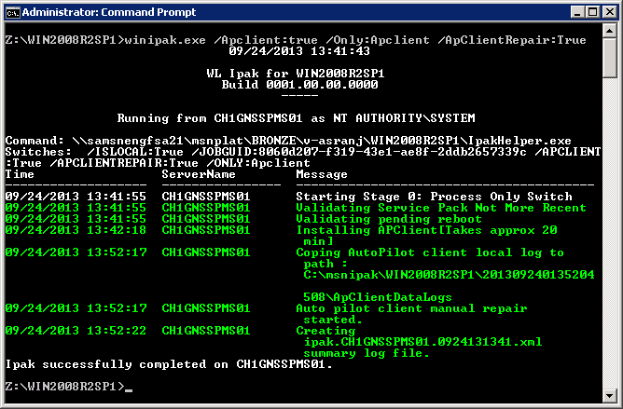  
  
To install and manual repair AP Client along with the Service other installations, use the following command:   
**Service.exe /APclient:true /ApClientRepair:True**

* For AP Client manual repair, use the following command:

**Service.exe /Only:Apclient /ApClientRepair:True**

1. **Verify successful install**

To verify whether AP Client has been successfully installed, check the existence of the following folders and components:

1. Service list will have a service named “Auto Pilot Service Manager”, as shown below.

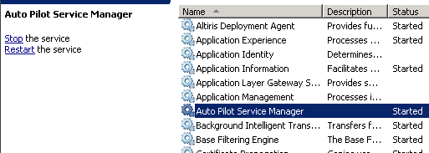

1. Drive “D” will have folders highlighted, as shown in the snapshot below:

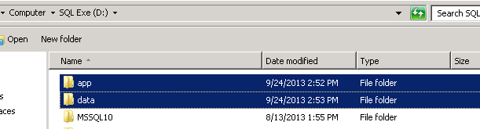

1. Drive “C” will have folder highlighted, as shown in the snapshot below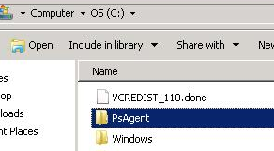

1. **Uninstalling AP Client through Service**

To uninstall AP Client through Service, use the following command:  
**Service.exe /Only:APClient /APCLIENTREMOVE:true**

1. **Uninstalling AP Client manually**

AP Client currently do not have a manual uninstall utility or function.   
To uninstall manually, follow these steps:

1. Stop AP Client service, as shown below.

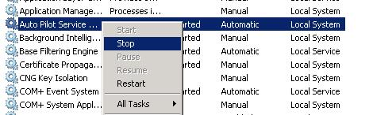

1. Open command prompt in Admin mode and delete AP Client service, use the following command:

**SC delete “apsvcmgr”**

1. Delete the **C:\PsAgent** folder, as shown below:

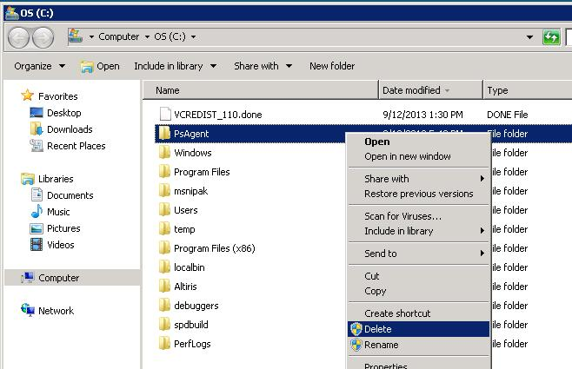

# Questions?

Contact [APCLIENTSUPPORT@Seattle-C.com](mailto:APCLIENTSUPPORT@Seattle-C.com) for any queries or assistance.